THIRD GRADE SUPPLIES

* 2 Horizontal pocket folders
* 2 boxes crayons (24 count)
* 2 boxes of colored pencils – sharpened (24 count)
* 2 boxes of #2 pencils – sharpened
* 1 ruler showing standard and metric measurement
* 4 washable glue sticks, .74 oz
* 1 pair Scissors (Fiskars is a good brand)
* 2 regular size boxes of tissues
* 1 large white “hi-polymer” eraser
* 2 boxes - 8 ct washable markers, classic colors, wide tip
* 2 boxes - 8 ct washable fine tip markers
* 2 yellow highlighter
* 2 black sharpie marker – fine tip
* 1 Zipper pencil pouch – no bigger than 9” x 5” OR plastic supply box 8” x 5” x 2”
* 1” three ring binder, hard cover
* 2 book soxs (large)
* 8 Post it notes packs - 3” x 3”
* 8 Post it notes packs - 1 ½” x 2”
* Large container Clorox wipes

**FOURTH GRADE SUPPLIES**

Individual Student List: **\*\*Please label with your child’s name**

* 1 pair of scissors
* 2 yellow highlighters
* 2 2” three ring binders
* 1 large glue stick
* 2 large erasers
* 1 Zipper pencil pouch–no bigger than 9” x 5”
* 2 book sox (large)
* 3 plastic Pocket Folders with 3 hole punched
* 2 black and white composition books
* 2 black sharpie markers
* 5 pack of Expo Black Dry Erase Markers
* 12 pencils (no mechanical pencils)
* 1 handheld pencil sharpener

Supplies to Share with Class:

**\*\*Please DO NOT label with your child’s name**

* 2 boxes (12 pk.) #2 pencils
* 2 pkg. pencil top erasers
* 1 large glue stick
* 1 pkg. colored pencils
* 1 box of markers (fat or thin)
* 1 box of crayons 24 count
* 2 boxes tissues
* 4 post it note packs 3” x 3”
* Large container Clorox wipes
* 1 box of sandwich or gallon size Ziploc bags

**BEAUMONT**

## **SUPPLY LIST\***

**For Kindergarten**

**Through Fourth Grade**

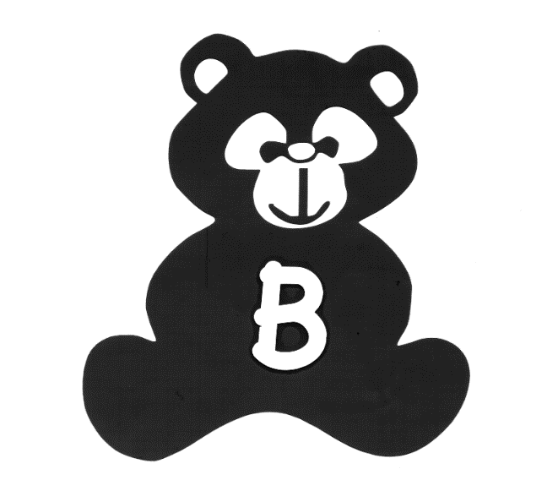

Beaumont Elementary School

575 Beaumont Road

Devon, PA 19333

(610) 240-1400

*Please replenish supplies at the beginning of each marking period

3/2/2018

**KINDERGARTEN SUPPLIES**

* * 1 backpack to be brought daily. Clearly label child’s name inside the bag.
* * 1 two-pocket folder, any style. Please put name on outside.
* NO PENCIL BOX IS REQUIRED (All supplies will be on tables)
* 1 set of earphones – Not EARBUDS (please place in gallon zip lock bag with your child’s name)

*Please do not label the following items. These will be community shared:*

* * All: One box gallon size zip-lock bags
* * Boys : 1 box quart size baggies; Girls: 1 box sandwich size baggies
* * 12-15 gluesticks (small) or 10 (large) (*white,* not purple, please.)
* * 1 bottles Elmer’s *White* School Glue, 8 oz.
* * 10-12 No. 2 pencils, SHARPENED
* * 2 boxes of 24 count *Crayola* crayon
* * 1 pair of *Fiskar’s* youth scissors
* * 1 box 8 count *Crayola* thick markers

* 2 boxes of Kleenex

* * 2 bottles of hand soap
* * 2 large pink erasers
* * 2 containers of Wet Ones Antibacterial wipes

**FIRST GRADE SUPPLIES**

* Pencils two dozen
* 1 Marble copy book
* 1 set of earphones – NOT EAR BUDS.
* Eraser (2 large pink)
* Crayons (one box of 24 regular size)
* 1 dozen Crayola colored pencils
* 1 pack Crayola Twistable crayons
* Small sharp pointed children’s scissors (Fiskars brand is good)
* One medium size Elmer’s glue – white only
* 8 large glue sticks – white only
* 4 solid color (Red, Yellow, Blue & Green) folders with horizontal pockets
* Crayola washable felt tip markers – set of eight, large size – classic colors only
* 1 1 ½ -inch 3-ring binder – Hardcover with plastic sleeve on front
* 1 large box of tissues
* 1 box of Ziploc bags (any size)
* 1 container of Wet Ones Antibacterial Wipes
* School box no bigger than 6” x 12” x 5” so it can fit in our desks (not cardboard) for holding all the above items with a **handle** on top and compartments inside. Example: fishing tackle box or cosmetic case.

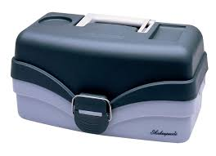

**SECOND GRADE SUPPLIES**

* 2 two pocket folder**s**
* 2 rolls scotch tape
* 2 dozen #2 Ticonderoga pencils - SHARPENED
* 2 Hi-Polymer white erasers
* 1 box of 24 crayons
* 8 count fat markers
* 1 small sharp pointed scissors (Fiskars brand is good)
* 1 large box of tissues
* 1 Elmer’s white glue
* 6 large glue sticks – white only
* 2 yellow highlighting markers
* 1 marble composition book (NOT college ruled)
* 1 pack of 5 post-it notes (3x3 size, light colors)
* 2 black Sharpies
* 1 pack of 4 Expo markers
* 1 3-ring binder (1 ½”) Hardcover with plastic sleeve on front
* School box no bigger than 6” x 12” x 5” so it can fit in the desk (not cardboard) for holding all the above items. A handle on top is most helpful to the child.